* WALK IT BACK : THE CHALLENGE OF A LIFETIME FOR THE FORMER COCA COLA EXECUTIVE TO REVERSE HIS CARBON FOOTPRINT

** CARBON REMOVAL : CANADIAN MILLIONAIRE WALKS FROM EUROPE TO ASIA BY FOOT TO FIND SOLUTIONS

**** WOULD YOU LIKE TO TALK ABOUT CARBON REMOVAL WHILE WALKING WITH AN EX-COCA-COLA EXECUTIVE?

****
FOR IMMEDIATE RELEASE : January 19 2023

On the eve of his 60th Birthday, former Coca-Cola executive and millionaire businessman Craig Cohon has embarked on a 4,000km walk from London to Istanbul to campaign for carbon removal. He will walk through Belgium between 26 January and 2 February (route below).

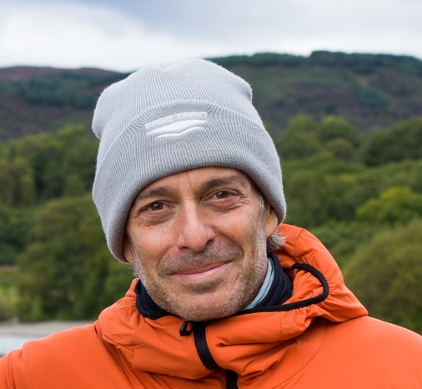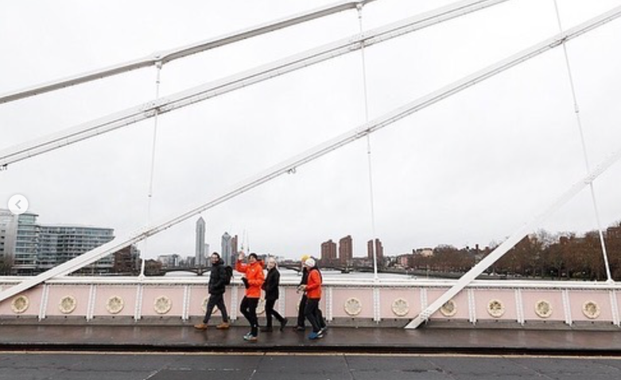

Craig Cohon is campaigning to change the course of our climate fate through campaigning for carbon removal.

This Canadian entrepreneur left London on January 3 for a 5-month journey that will take him over 4,000 km across Europe on foot. He should arrive in Istanbul on June 4, the eve of his sixtieth birthday.

Cohon will cross the border from France to Belgium on 26 January, arriving in Ronquieres on 26 January. He will reach Brussels on 28th and set off towards the Netherlands on 30 January.

For years, Craig Cohon travelled the world on behalf of large companies such as Coca-Cola and Cirque du Soleil before settling on a barge on the banks of the River Thames thirteen years ago.

In 2022, Craig launched the walk it back campaign after becoming the ﬁrst private citizen to undertake a personal ‘lifetime carbon audit’ following COP26. This process saw him calculate in

molecular detail how many tonnes of carbon he’d emitted over decades of fast living: high-rolling holidays, lots of ﬂights and innumerable hamburgers. In November, he repaid what he calls his debt to the earth – giving over USD $1 million of his pension to carbon removal projects.

walk it back sets out to revolutionise how carbon removal is perceived and supported globally: calling for greater dialogue, coordination, knowledge, governance and investment in the sector in order to safely and quickly scale carbon removal solutions.

Cohon says: “I was so clueless about all this stuff, but when I learnt that all the carbon we’ve emitted is still up there I started looking into carbon removal. What I discovered is that it takes a lot of work and money, but it’s possible to get huge quantities of CO2 out of the atmosphere. The tech is there and improving all the time. But we really do need to get quicker and better at doing this, fairly and on a huge scale. If we succeed, it has the potential to actually change the course of climate history.”

Founder members of the campaign include youth climate activist network ReEarth Initiative and city leadership networks United Cities and Local Governments. Partners include climate platform Patch, the bank, EFG, and the investment firm Searchlight Capital.

In November 2022, walk it back published the paper Getting to Net Negative that highlights the critical role cities play in carbon removal, and Cohon’s walk will feature special events in 10 cities along his route that engage city decision-makers. In London, for example, untapped carbon sequestration opportunities include afforesting the statutory Green Belt, the 1,269,800 acres of land that encircles the city: with huge co-beneﬁts for air pollution and physical and mental health.

MEDIA OPPORTUINITES (26 JAN – 2 FEV)

28-29-30 JANUARY (BRUSSELS))

Requests for interviews with Craig Cohon (walk it back) et ReEarth Initiative should be sent to jenny@walkitback.org or by text/whatsapp au +447487820326
Please include your name and the outlet you work for.

Interview format: by phone, face-to-face, or walking with Craig.

More footage available on request

BELGIAN ROUTE

26/01/2023 Saint-Symphorien – Ronquieres
27/01/2023 Ronquieres – Beersel

28/01/2023 Beersel – Brussels Belgium

14h00 Rendez Vous Palais de Justice. Walkers, activists and WEF’s Global Shapers walk to Grand Place and meet at a café for a fireside chat with Craig. Open to public and media.

29/01/2023 Brussels (Rest Day)
30/01/2023 Brussels – Rumst

08h30 – 09h30 walk it back & Carbon Gap co-host breakfast meeting with decision makers, NGOS and activists (Venue TBC)

31/01/2023 Rumst – Brasschaat
1/2/2023 Brasschaat – Roosendaal
2/2/2023 Roosendaal – Willemsdorp

MEDIA PACK

Film here
Stills here
Website: https://walkitback.org/

Find more information on @2023walkitback on:
Twitter | Instagram | Facebook | LinkedIn | TikTok

