* WALK IT BACK : THE CHALLENGE OF A LIFETIME FOR THE FORMER COCA COLA EXECUTIVE TO REVERSE HIS CARBON FOOTPRINT

** CARBON REMOVAL : CANADIAN MILLIONAIRE WALKS FROM EUROPE TO ASIA BY FOOT TO FIND SOLUTIONS

**** WOULD YOU LIKE TO TALK ABOUT CARBON REMOVAL WHILE WALKING WITH AN EX-COCA-COLA EXECUTIVE?

****
FOR IMMEDIATE RELEASE : January 30 2023

On the eve of his 60th Birthday, a former Coca-Cola executive and millionaire businessman has embarked on a 4,000km walk from London to Istanbul to campaign for carbon removal. He will walk through the Netherlands between February 1st and February 13th (route below).

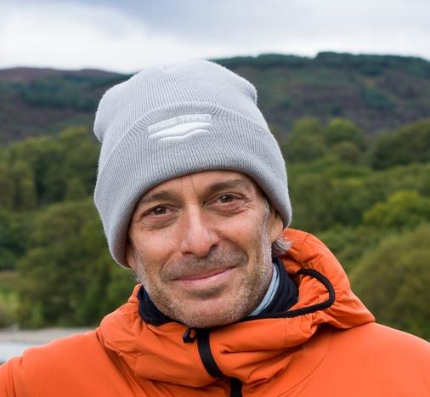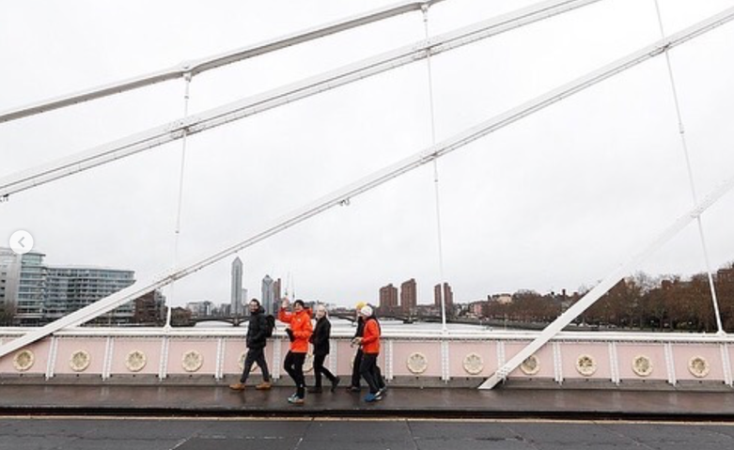

Craig Cohon is campaigning to change the course of our climate fate through carbon removal technologies.

This Canadian entrepreneur left London on January 3 for a 5-month journey that will take him over 4,000 km across Europe on foot. He should arrive in Istanbul on June 4, the eve of his sixtieth birthday.

Cohon will cross the border from Belgium to the Netherlands on 1 February, arriving in Roosendaal on that day. He will reach Amsterdam on 6 February and set off towards Germany on 13 February.

For years, Craig Cohon traveled the world on behalf of large companies such as Coca-Cola or Cirque du Soleil before settling on a barge on the banks of the River Thames thirteen years ago.

In 2022, Craig launched the walk it back campaign after becoming the ﬁrst private citizen to undertake a personal ‘lifetime carbon audit’ following the UN Climate Change Conference (COP26). This process saw him calculate in molecular detail how many tonnes of carbon he’d emitted over decades of fast living: high-rolling holidays, lots of ﬂights and innumerable hamburgers. In November he repaid what he calls his debt to the earth – giving over $1m of his pension to carbon removal projects.

Walk it back sets out to revolutionise how carbon removal is perceived and supported globally: calling for greater dialogue, coordination, knowledge, governance and investment in the sector in order to safely and quickly scale carbon removal solutions.

Cohon says: “I was so clueless about all this stuff, but when I learnt that all the carbon we’ve emitted is still up there I started looking into carbon removal. What I discovered is that it takes a lot of work and money, but it’s possible to get huge quantities of CO2 out of the atmosphere. The tech is there and improving all the time. But we really do need to get quicker and better at doing this, fairly and on a huge scale. If we succeed, it has the potential to actually change the course of climate history.”

Founder members of the campaign include youth climate activist network ReEarth Initiative and city leadership networks United Cities and Local Governments. Partners include de climate platform Patch, the EFG bank and the investment firm Searchlight Capital.

In November 2022, walk it back published the paper Getting to Net Negative that highlights the critical role cities play in carbon removal, and Cohon’s walk will feature special events in 10 cities along his route that engage city decision-makers. In London, for example, untapped carbon sequestration opportunities include afforesting the statutory Green Belt, the 1,269,800 acres of land that encircles the city: with huge co-beneﬁts for air pollution and physical and mental health.

MEDIA OPPORTUNITES (1 FEB – 13 FEB)

6-7-8 FEBRUARY (AMSTERDAM)

Requests for interviews with Craig Cohon (walk it back) et ReEarth Initiative should be sent to jenny@walkitback.org or by text/whatsapp at +447487820326
Please include your name and the outlet you work for.

Interview format : by phone, face to face, or walking with Craig.

More footage available on request

NETHERLANDS ROUTE

1 Feb | Brasschaat (Belgium) | Roosendaal
2 Feb | Roosendaal | Willemsdorp
3 Feb | Willemsdorp | Bergambacht
4 Feb | Bergambacht | Woerden
5 Feb | Woerden | Nes aan de Amstel
6 Feb | Nes aan de Amstel | Amsterdam
7 Feb | Amsterdam | Amsterdam
8 Feb | Amsterdam | Almere Haven
9 Feb | Almere Haven | Vanenburg
10 Feb | Vanenburg | Wenum
11 Feb | Wenum | Dijkerhoek
12 Feb | Dijkerhoek | Almelo
13 Feb | Almelo | Nordhorn (Germany)

MEDIA PACK

Film here
Stills here
Website: https://walkitback.org/

Find more information on @2023walkitback on:
Twitter | Instagram | Facebook | LinkedIn | TikTok

